**Rhalp’s Calculator**

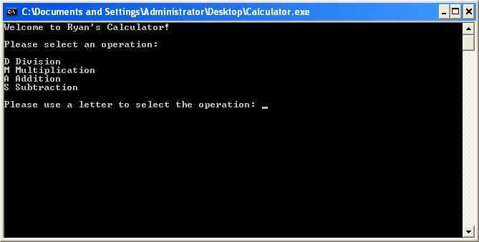#include <iostream>

using namespace std;

float division (float a, float b)

{

float r;

r=a/b;

return (r);

}

float multiplication (float a, float b)

{

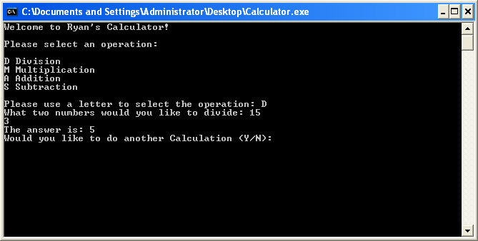 float r;

r= a*b;

return (r);

}

float addition(float a, float b)

{

float r;

r=a+b;

return(r);

}

float subtraction(float a, float b)

{

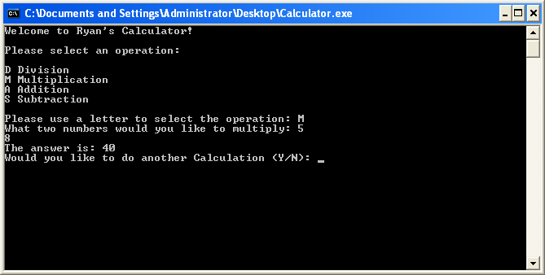 float r;

r=a-b;

return(r);

}

int main()

{

char opselect;

bool playagain = true;

char playagainchar;

float ma;

float mb;

float ans;

cout<<"Welcome to Simple Calculator!\n\n";

while (playagain == true)

{

cout<<"Please select an operation:\n\n";

cout<<"D Division \nM Multiplication \nA Addition \nS Subtraction \n\n";

cout<<"Please use a letter to select the operation: ";

cin>>opselect;

if (opselect == 'D' || opselect == 'd')

{

cout<< "What two numbers would you like to divide: ";

cin>>ma;

cin>>mb;

ans = division (ma, mb);

cout<<"The answer is: "<<ans<<"\n";

cout<<"Would you like to do another Calculation (Y/N): ";

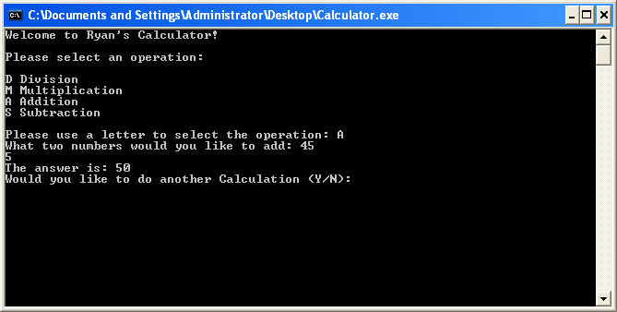 cin>>playagainchar;

cout<<"\n\n";

if(playagainchar != 'y') playagain = false;

}

if (opselect == 'M' || opselect == 'm')

{

cout<< "What two numbers would you like to multiply: ";

cin>>ma;

cin>>mb;

ans = multiplication (ma, mb);

cout<<"The answer is: "<<ans<<"\n";

cout<<"Would you like to do another Calculation (Y/N): ";

cin>>playagainchar;

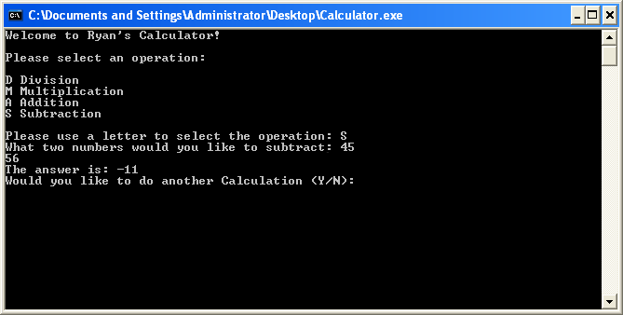 cout<<"\n\n";

if(playagainchar != 'y') playagain = false;

}

if (opselect == 'A' || opselect == 'a')

{

cout<< "What two numbers would you like to add: ";

cin>>ma;

cin>>mb;

ans = addition (ma, mb);

cout<<"The answer is: "<<ans<<"\n";

cout<<"Would you like to do another Calculation (Y/N): ";

cin>>playagainchar;

cout<<"\n\n";

if(playagainchar != 'y') playagain = false;

}

if (opselect == 'S' || opselect == 's')

{

cout<< "What two numbers would you like to subtract: ";

cin>>ma;

cin>>mb;

ans = subtraction (ma, mb);

cout<<"The answer is: "<<ans<<"\n";

cout<<"Would you like to do another Calculation (Y/N): ";

cin>>playagainchar;

cout<<"\n\n";

if(playagainchar != 'y') playagain = false;

}

}

cout<<"Thanks for calculating!";

cin.get();

return 0;

}